CST 391 – Web Application Development
Activity 2: Angular Test Application
Student Name: Oluwaseun Akerele
Course: CST 391
Date: February 2, 2026

Angular Test Application
Introduction
This activity focuses on setting up and exploring a basic Angular application using the Angular CLI. The goal is to understand the default project structure, run the application locally, and make simple modifications to the user interface. By inspecting key folders and configuration files, this activity builds foundational knowledge of how Angular applications are created, organized, and rendered in a web browser

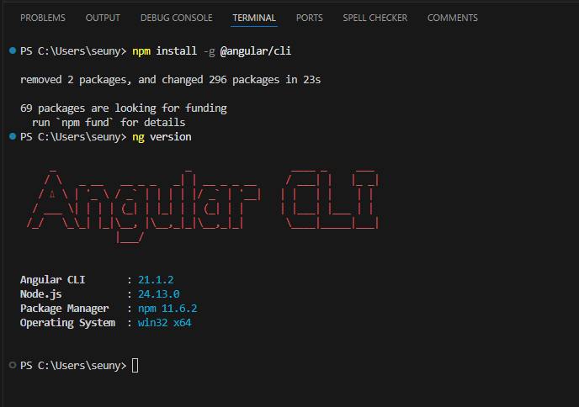
Angular CLI was installed successfully and verified using the ng version command.
Explanation:
The npm install command installed the Angular CLI globally on the system. Running the ng version command confirmed the installation and displayed the installed Angular CLI version along with Node.js and npm details. This verification ensures the development environment is properly configured to create and run Angular applications.

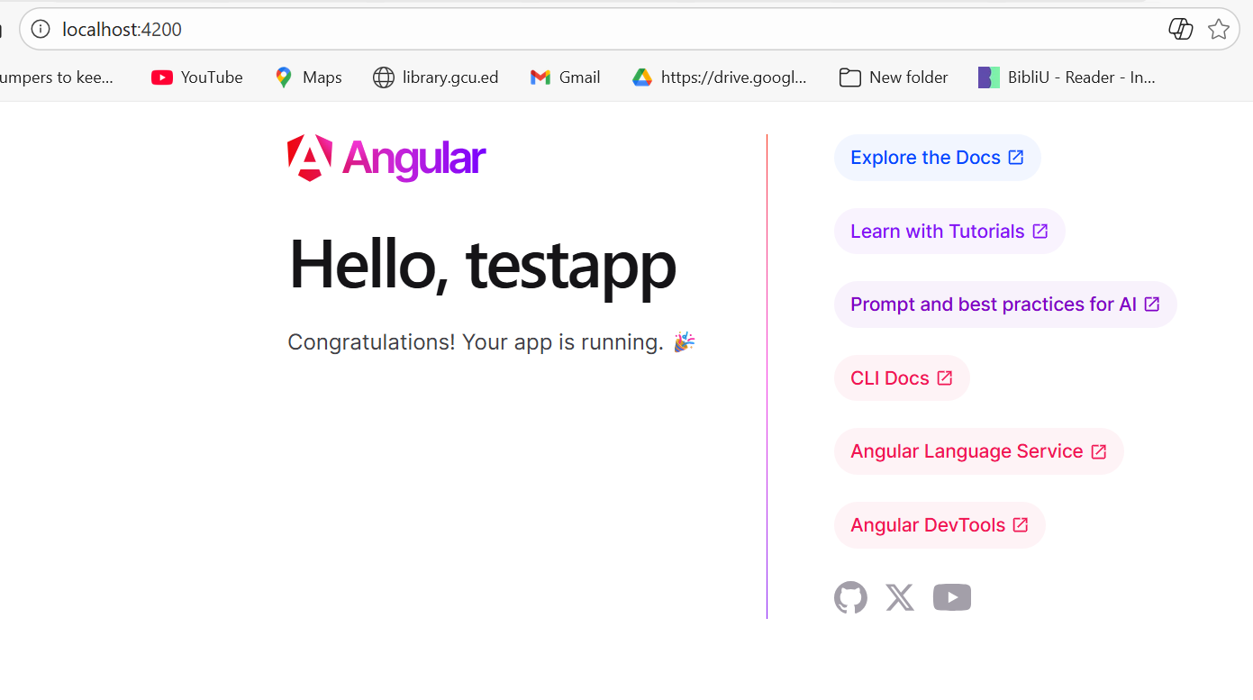
Angular test application successfully launched on localhost using the Angular CLI.
Explanation:
The Angular CLI generated the testapp project and started the development server using the ng serve command. The application compiled without errors and was served on localhost port 4200. This confirms the project setup is correct and the Angular environment is functioning as expected.
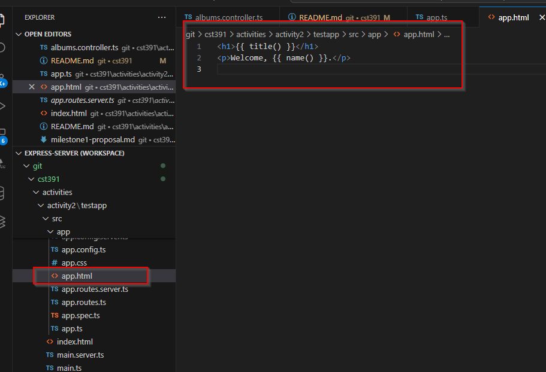
Application template updated to display dynamic title and custom message using Angular signals.
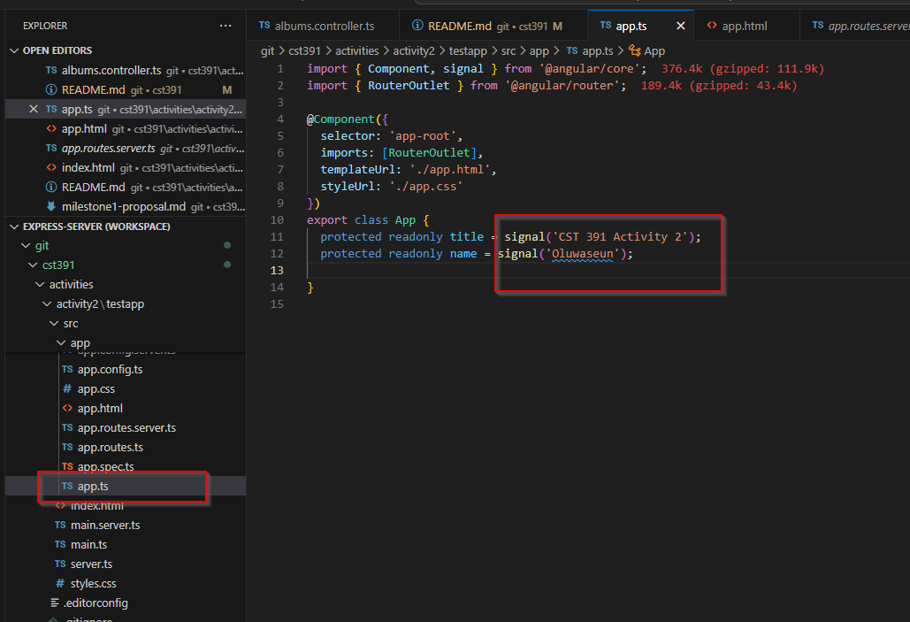
Application component updated with custom title and name using Angular signals.

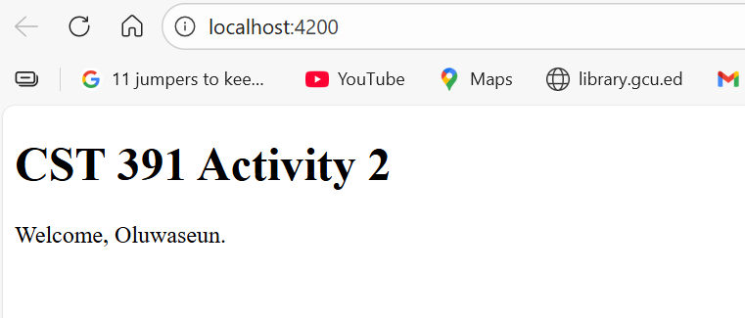
Updated Angular application successfully rendered in the browser with customized content.
Explanation:
After updating the component logic and template, the Angular development server recompiled the application and refreshed the browser automatically. The page now displays the new application title and personalized welcome message, confirming that data binding between the component and the view is working correctly.

3a. Project structure and key files

Folders
node_modules
This folder holds all third party libraries your project depends on. When you run npm install, npm downloads packages into node_modules. Angular uses these packages to build and run the app. Developers normally do not edit anything inside this folder. It can be deleted and rebuilt if needed.
src
This is the main source folder for your application. Most of the code you write lives here, including components, templates, styles, and configuration files that Angular uses to build the app.
src/app
This folder contains the core Angular application code. It includes the main component, routing, services, and other files that define what the app does. If you are changing what the app shows on screen, you usually start here.
src/assets
This folder is for static files that should be copied directly into the build output, such as images, icons, and sometimes JSON files. Angular does not compile these files, it simply makes them available to the application.
src/environments
This folder contains environment configuration files. It is commonly used to store different settings for development vs production, like API URLs, feature flags, or debug settings. Angular can swap these files automatically depending on how you build the app.

Files
angular.json
This is the Angular workspace configuration file. It tells Angular CLI how to build and serve the project. It includes settings for build output, assets, styles, scripts, and project level options used during development and production builds.
package.json
This file describes the Node project. It contains the project name, version, dependencies, and scripts. The scripts section controls commands like running the dev server or building the app. The dependencies section lists the packages required to run Angular and any libraries you install.
tsconfig.json
This is the TypeScript configuration file. It controls how TypeScript compiles into JavaScript. It defines things like compiler rules, strictness, target JavaScript version, and which files are included in the compilation.

3b. How Angular generated the default page
When you run ng serve, Angular CLI starts a development server and builds the application in memory. The browser loads the app from localhost and Angular generates the page by bootstrapping the application, loading the root component, and rendering its template into the page.
Here is how the listed files work together:
main.ts
This is the entry point of the application. It bootstraps the Angular app, meaning it tells Angular to start running and load the root configuration that launches the first component.
app.component.ts
This file contains the logic for the root component. It defines the component class, stores values (like title or name), and controls what data can be displayed in the UI.
app.component.html
This is the template for the root component. It contains the HTML that the user sees in the browser. Angular uses data binding syntax like {{ }} to display values from the component class inside the HTML.
app.component.css
This file contains styles for the root component. These styles affect how the component looks on screen and are typically scoped to that component so they do not accidentally style other parts of the app.
app.module.ts
This file defines the root Angular module. The module groups components and imports, and it helps Angular understand what belongs to the application. The module connects the pieces together so Angular knows what to load and how the app is structured.

